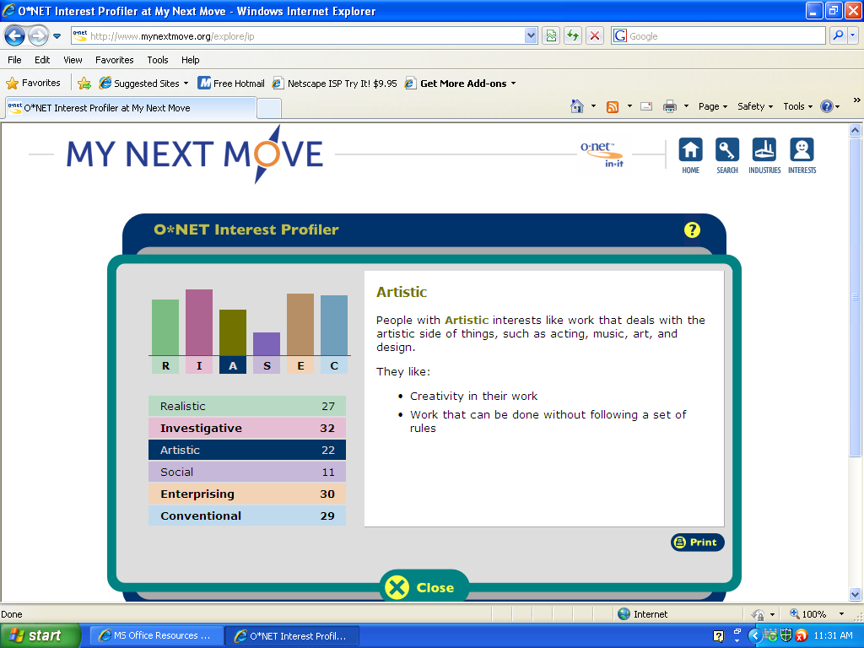
My top three personality types are Investigative, Enterprising, and Conventional. I agree with this as I feel comfortable with jobs in these areas. I am still unsure as to what job I will choose or the type I will choose.
Civil Engineer
Chemical Engineer
Aerospace Engineer
Biomedical Engineer
Anthropologist
Archaeologist
Historian
Marketing Research Analyst
Political Scientist
Market or Survey Researcher
HR1. What is the definition of each occupation that your group has chosen and the nature of the work?
Archeology & Anthropology- Anthropologists and Archeologists Study the origin, development, and behavior of human beings. They may study the way of life, language, or physical characteristics of people in various parts of the world. They may engage in systematic recovery and examination of material evidence, such as tools or pottery remaining from past human cultures, in order to determine the history, customs, and living habits of earlier civilizations.
Civil Engineer- Civil Engineers are those who design and supervise the construction of roads, buildings, airports, tunnels, dams, bridges, and water supply and sewage systems. They create and design structures while remembering factors such as budget, lifetime, government regulations, and natural disasters.
Historian- Historians research, analyze, and interpret the past. They use many sources of information in their research, including government and institutional records, newspapers and other periodicals, photographs, interviews, films, and unpublished manuscripts such as personal diaries and letters. Historians usually specialize in a country or region, a particular period, or a particular field, such as social, intellectual, cultural, political, or diplomatic history. Many communicate their research and findings through books, articles, or essays.
Political Scientists- Political Scientists conduct research on a wide range of subjects, such as relations between the United States and other countries, the institutions and political life of nations, the politics of small towns or major metropolises, and the decisions of the U.S. Supreme Court. Studying and evaluating topics such as public opinion, political decision making, ideology, and public policy, they analyze the structure and operation of governments, as well as various other entities. Depending on the topic, a political scientist might analyze a public-opinion survey, study election results or public documents, or interview public officials. Occasionally, they may collaborate with government economists to assess the effects of specific changes in legislation or public policy, such as the effects of the deregulation of industries or of changes in Social Security. Through academic publications, written reports, or public presentations, political scientists present their research reports and often identify new issues for research and analysis. Many political scientists forecast political, social, and economic trends.
Market or survey researchers- Market or survey researchers gather information about what people think. Market research analysts help companies understand what types of products people want, determine who will buy them and at what price. Gathering statistical data on competitors and examining prices, sales, and methods of marketing and distribution, they analyze data on past sales to predict future sales.
Market research analysts- devise methods and procedures for obtaining the data they need by designing surveys to assess consumer preferences. While a majority of surveys are conducted through the Internet and telephone, other methods may include focus group discussions, mail responses, or setting up booths in public places, such as shopping malls, for example. Trained interviewers usually conduct the surveys under a market research analyst's direction.
Aerospace engineers- design, test, and supervise the manufacture of aircraft, spacecraft, and missiles. Those who work with aircraft are called aeronautical engineers, and those working specifically with spacecraft are astronautical engineers. Aerospace engineers develop new technologies for use in aviation, defense systems, and space exploration, often specializing in areas such as structural design, guidance, navigation and control, instrumentation and communication, and production methods. They also may specialize in a particular type of aerospace product, such as commercial aircraft, military fighter jets, helicopters, spacecraft, or missiles and rockets, and may become experts in aerodynamics, thermodynamics, celestial mechanics, propulsion, acoustics, or guidance and control systems.
Chemical engineers- apply the principles of chemistry to solve problems involving the production or use of chemicals and other products. They design equipment and processes for large-scale chemical manufacturing, plan and test methods of manufacturing products and treating byproducts, and supervise production. Chemical engineers also work in a variety of manufacturing industries other than chemical manufacturing, such as those producing energy, electronics, food, clothing, and paper. In addition, they work in healthcare, biotechnology, and business services. Chemical engineers apply principles of physics, mathematics, and mechanical and electrical engineering, as well as chemistry. Some may specialize in a particular chemical process, such as oxidation or polymerization. Others specialize in a particular field, such as nanomaterials, or in the development of specific products. They must be aware of all aspects of chemical manufacturing and how the manufacturing process affects the environment and the safety of workers and consumers.
Biomedical engineers- develop devices and procedures that solve medical and health-related problems by combining their knowledge of biology and medicine with engineering principles and practices. Many do research, along with medical scientists, to develop and evaluate systems and products such as artificial organs, prostheses (artificial devices that replace missing body parts), instrumentation, medical information systems, and health management and care delivery systems. Biomedical engineers also may design devices used in various medical procedures, imaging systems such as magnetic resonance imaging (MRI), and devices for automating insulin injections or controlling body functions. Most engineers in this specialty need a sound background in another engineering specialty, such as mechanical or electronics engineering, in addition to specialized biomedical training. Some specialties within biomedical engineering are biomaterials, biomechanics, medical imaging, rehabilitation engineering, and orthopedic engineering.
HR2. What are some of the related occupational fields?
Civil Engineer- Related occupational fields include Surveyors, Drafters, other types of Engineering, Mathematicians.
Archeology & Anthropology- Sociology, History, Demography, Human Geography.
Historian- Geographers, Archaeologists, Social scientists, Anthropologists
Political Scientists- Sociologists, Psychologists, Economists, Statisticians
Market or survey researchers- Marketing Research Analyst, survey researcher, market opinion researcher.
Market research analyst: survey researcher, market opinion researcher.
Chemical engineer- Nuclear engineers, Materials engineers, Environmental engineers
Biomedical engineer- Biochemists, Biological scientists, Chemist
Aerospace engineer- physicist, Atmospheric scientists, Astronomer
HR3. Which personality type(s) is best suited to the occupations/jobs you have researched?
Investigative is the personality type associated with these occupations and is therefore best suited.
HR4. What kind of education, training and qualifications are required?
Civil Engineer- A bachelor’s degree is standard however you must be a licensed to provide your services to the public and many engineers hold official professional engineer certification.
Archeology & Anthropology- A Bachelor’s degree is needed for entry level positions. Master’s and Doctoral degree levels are necessary for higher ranking positions in this field of science. To conduct research and teach a P.H.D. is required.
Historian- A bachelors’ degree is needed to start but to get any real noteworthy recognition you need a master’s or even doctorate to get anywhere.
Market or survey researchers- A bachelor’s degree will start you off, but you need more education (master’s) to continue.
Political Scientists- A master’s degree is the most worthwhile as many positions can be attained with it while a bachelor’s degree will only allow for a less advanced role.
Market Research Analyst- A bachelor’s degree is the BARE minimum to get a good position you need a master’s and take courses in sociology, economics, business, and mathematics.
Biomedical engineer- A bachelor’s degree is for an entry-level position and by using other degrees (chemistry, biology, anatomy).
Aerospace engineer- A bachelor’s degree starts you off but, many aerospace engineers have training in mechanical engineering. This flexibility allows employers to meet staffing needs in new technologies and specialties in which engineers may be in short supply.
Chemical engineer- a bachelor’s degree gets you an entry level position, but advanced chemistry courses are absolutely required for this job.
HR5. What technology skills are needed to be successful in the career/occupational fields you have explored?
Civil Engineer- You must have skills in technical and computer work, along with schematics, maps, and drafting software.
Archeology & Anthropology- You must use skills in chemistry, biology (anatomy), English (reports), and geography and history.
Historian- Skills in English and research are best used in this field.
Political Scientists- Computer use is in formatting papers is required.
Market or survey researchers- Advanced Research skills and good presentations.
Market Research analyst- You need to use advanced skill in excel, make large organized charts, devise presentations to your peers and analyze what people want now.
Biomedical engineer- you need degrees in biology, chemistry, and anatomy. On top of that you must be observant.
Aerospace engineer- Physics and Mathematics is a must because you will need to determine the flight of objects and have knowledge and understanding of how flight occurs.
Chemical engineers- Mathematics is a must but knowledge and caution when working with chemicals is required for some elements and compounds are highly dangerous.
RC1. What does each occupation pay, or what are the average earnings nationally and in this area of the country?
Civil Engineer- Annually Civil Engineers earn about $74,600 on a national scale and $85,390- $94,970 in Massachusetts. The lowest 10% gets $50,560 a year, and the highest ten percent earns $119,320.
Archeology & Anthropology- Nationally, Archeologists and Anthropologists earn $58,040 annually. In Massachusetts Archeologists and Anthropologists earn between $66,360 and $92,570 annually. The lowest ten percent earns $41,320 and the highest a $128,690.
Historian- Nationally Historians have earned a mean annual pay of $57,840. In Massachusetts the annual pay is between $60,030 and $69,900. The highest ten percent earns $95,690 and the lowest ten percent earns about $26,370.
Political Scientists- Nationally $104,130 and for Mass no data was available.
Market or survey researchers- Nationally $36,210, in Mass. $41,720 to $49,320.
Market Research Analyst- Nationally they earn around $61,070 annually and earn $71,080 – $82,920
Biomedical engineers- earn $87,960- $152,180 in Massachusetts alone per year, Nationally they make about $84,780 per year.
Aerospace engineers- Nationally they make about $99,000 and in Massachusetts they make about $99,250- $106,680.
Chemical engineers- make an average of about $94,590 a year nationally and in Massachusetts they make $87,530 - $89,570 annually.
RC2. What is the projected growth for this career field over the next 10 years? (I.e. will there be more or less jobs like this in the future?)
Civil Engineer- The projected growth of this field is about 24 percent over the decade.
Archeology & Anthropology- The projected growth of this field is about 28 percent over the decade.
Historian- The projected growth of this field is around 22 percent over the decade.
Political Scientists- The projected growth of this field is around 21 percent over the decade.
Market or survey researchers- The projected growth of this field is 28 percent over the decade.
Market Research Analysts- The projected job growth of this field is 28 percent over the decade.
Chemical engineers- are expected to have an employment decline of 2 percent over the projections decade.
Biomedical engineer- are expected to have employment growth of 72 percent over the projections decade.
Aerospace engineer- are expected to have 10 percent growth in employment over the projections decade.
RC3. Please identify local or national organizations that would hire someone in each career field you have explored.
Civil Engineer- American Society of Civil Engineers, Federal Government
Archeology & Anthropology- North American Chronology, Society for American Archaeology, Native American Heritage Museum.

Historian- American Historical Association, World History Association,
Political Scientists- American Political Science Association, Western Political Science Association
Market or survey researchers- American research association
Market research analyst- May have civil service unions in other states I was unable to find one, they can work for the government.
Biomedical engineers- Federal Government, Biomedical Engineering Society
Chemical engineers- Federal Government, American Chemical Society, American Institute of Chemical Engineers
Aerospace engineers- American Institute of Aeronautics and Astronautics
ISC1. What are the working conditions or work environment for each job you or your group decided to research (such as work schedule, hours, exempt/salaried or non-exempt/hourly, etc.)?
Civil Engineer- 40 hour workweek with some overtime, benefits include health insurance, sick leave, paid vacation. Settings can range from offices to field work in remote locations.
Archeology & Anthropology- Work schedule for Archeologists and Anthropologists are irregular because the job is mostly preparation for the publication of your work. The job can call for you to make time.
Historian- More than 40 hours per week mostly confined in an office studying and analyzing records. Researching certain periods and learning more about the weird details.
Political Scientists- work 120 hours a week making papers of work on the politics of the U.S. and other nations.
Market or survey researchers- 70 hours per week making statistical charts and analyzing stock data, doing presentations and managing massive amount of data.
Market research analysts- Market and survey researchers generally have structured work schedules. They often work alone, writing reports and preparing statistical charts on computers, but they sometimes may be part of a research team. Market researchers who conduct personal interviews have frequent contact with the public. Most work under pressure of deadlines and tight schedules, which may require overtime.
Chemical engineers- work a standard 40-hour week while working in a laboratory.
Biomedical engineers- work a standard 40-hour week with the bulk of it in a lab doing tests.
Aerospace engineers- work a standard 40-hour week most of the time is spent in a lab with special Aeronautical equipment.
ISC2. Are positions in this career field typically part of collective bargaining units (unions)?
Civil Engineers- Yes, there are unions for Civil Engineers such as and some jobs give union wages.
Archeology & Anthropology- Not really considering that certain thing are irregular.
Historian- Historical preservation societies fill that role such as American Historical Association.
Political Scientist- Associations provide the functions unions do such as the American Political Science Association
Market or survey researchers- If there is one I have not found it.
Chemical engineers- American Chemical Society, American Institute of Chemical Engineers
Biomedical engineers- Biomedical Engineering Society
Aerospace engineers- American Institute of Aeronautics and Astronautics
ISC3. What kind of opportunities for advancement are there for each career? (i.e. Is there a chance to get promoted, etc.?)
Civil Engineer-Yes, There is room for promotion such as field crew leader, manager and assistant manager, ect.
Archeology & Anthropology- No, you can improve your credibility though.
Historian- Gain degrees along with more convincing ideas.
Political Scientists- No, credibility is the method.
Market or survey researchers- Yes, head researcher and stuff like that.
Market Research Analyst-Market research analysts often begin their careers by assisting others prior to being assigned independent research projects. With experience, continuing education, and advanced degrees, they may advance to more responsible positions in this occupation.
Chemical engineers- graduates usually work under the supervision of experienced engineers and, in large companies, also may receive formal classroom or seminar-type training. As new engineers gain knowledge and experience, they are assigned more difficult projects with greater independence to develop designs
Biomedical engineers- graduates usually work under the supervision of experienced engineers and, in large companies, also may receive formal classroom or seminar-type training. As new engineers gain knowledge and experience, they are assigned more difficult projects with greater independence to develop designs
Aerospace engineers- graduates usually work under the supervision of experienced engineers and, in large companies, also may receive formal classroom or seminar-type training. As new engineers gain knowledge and experience, they are assigned more difficult projects with greater independence to develop designs
Bibliography
Bureau of Labor Statistics

ANALYSIS:
I narrowed my career choices down to the careers Civil Engineer, Anthropologist, and Biochemical Engineer. I did this by viewing the job data of each job, calculating the probability of me finding such a job and then selecting by average salary. The jobs I had little interest in were quickly removed at the beginning, solving such a problem. At the end these are the jobs I was going to like doing, have an easy time finding, and have a decent pay.

